Steps to Run sample JavaScript program:

Step 1: Create a new file in VS Code and save the file in your directory as “sample.html”

Step 2: Copy paste the below code into the created file and save the file.

<script>
var stringName = 'Lorem Ipsum is simply dummy text of the printing and typesetting industry.';
var letter = 't';
function findCharCount(stringName, letter)
{
console.log("No. of characters in a string",stringName.length);
var count = 0;
for (var i = 0; i < stringName.length; i++)
{
if (stringName.charAt(i) == letter)
{
count += 1;
}
}
console.log("Total no. of similiar characters",count);
};
findCharCount(stringName, letter);

</script>

Step 3: Once saved, go to the file location and open the file with Chrome.
Step 4: Once Chrome open’s its display a blank screen to check the output, Right Click and click on Inspect as shown below
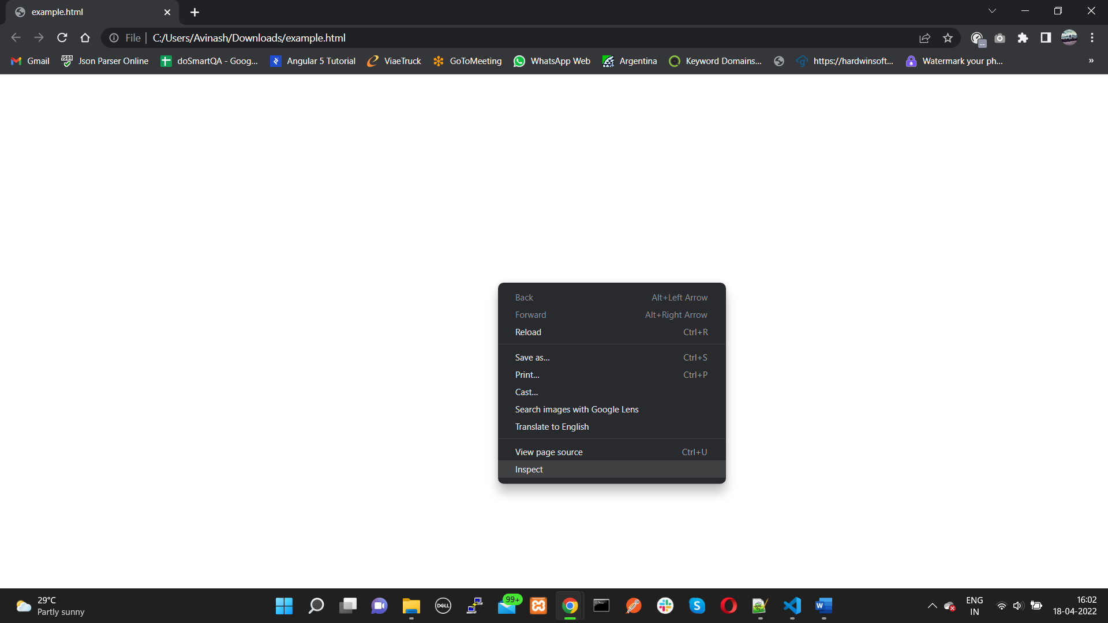

Go to Console to check the Output.
